Prof. Henry Janzen  Fall 2003 | Trinity Western University MA 101 Finite Mathematics  Chapter 5 Test | Name: ____________________
Directions: Show all your work, draw diagrams where appropriate. Simplify all answers.

- Solve each equation and simplify your answers.

- 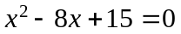 | - 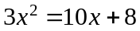
- 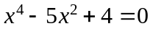 | - 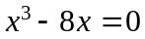
- Sketch each parabola
  - Show the vertex
  - Show two symmetric points
- 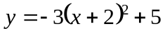  y  y  x  x | - 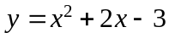

- Sketch the parabola and determine its equation from the information given.
Given: The Vertex (-2, 3) and the y-intercept is (0, 1).
- You need to build a rectangular pen against an existing wall. What should the dimensions of the pen be, if you wish to maximize the area with 180 meters of available fencing?
Hint: Let the equal sides be x.
y
x
    - Write a function of Area in terms of x.
A
    - Sketch the function.
B
    - What is the maximum area possible?
- Mary bought a number of calculators for a total of $240.00. She kept one for herself and sold the rest for $300.00 making a profit of $5.00 per calculator sold. How many calculators did she buy.
Hint: Let "n" be the number of calculators purchased by Mary, and "p" be the price per calculator that she paid.
Note: You must show all equations and their solutions for full marks.
- Given the demand and supply functions, determined by
    - 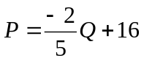 (Demand function)
    - 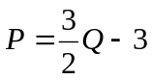 (Supply function)
  - Calculate the Equilibrium point.
  - From the demand function, determine the Revenue function. Hint: R=P⋅Q
  - Use the revenue function to determine the maximum revenue possible.
  - If the cost function for problem #6 is given as 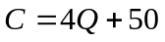, determine:
    - The break even point and,
    - The maximum profit.

